**Berwyn Heights Stormwater Dashboard Project**

Avani Badugu, John Spurrier, Emily Klomparens, Prince Okpoziakpo, Jay Mathur

**Abstract**

Berwyn Heights is a small town in Prince George’s County, Maryland, with a population of ~3000 residents. According to www.riskfactor.com, there are 112 properties at risk of being severely flooded within the next 30 years. The Town of Berwyn Heights (referred to as “the client” from hereon) requested a data dashboard that tracks/displays stormwater and/or flooding-related information. The mission of our project was to help elected officials and residents mitigate flood/stormwater-related issues. The original statement of work was to create visualizations using different tools to create a dashboard that would display our research and findings. From speaking with the client multiple times, our statement of work slightly changed. We decided that our dashboard would be implemented as a multi-layer ArcGIS map.

Our form of communication to develop our research and deliverables was with Christopher Brittan-Powell, our primary point of contact. He currently serves as the Mayor Pro Tem for Berwyn Heights and was previously an associate professor in the psychology department at Coppin State University in Baltimore, Maryland. Charley Griffith is a civil engineer and our data expert whom we were introduced to by Christopher Powell. Charley provided the resources we needed to extract data for the ArcGIS map.

**Methods**

To start the project, we did background research on the town of Berwyn Heights and flooding statistics to familiarize ourselves with the area. To fulfill the requirements of our statement of work, we collected open-source data and utilized data provided by the client. We spent time sorting through data provided by Charley and narrowed down what we wanted to use, which was hydrology aspects. Then, we created a low-fidelity prototype sketch to chart how we want to display our data. The team had to set aside time to familiarize themselves with the ArcGIS platform in order to build our dashboard according to our prototype because we were all new to the platform. Lastly, we incorporated our data into the dashboard to create a layered map. After visualizing our data, we had to make generalized recommendations for the town because the data did not specifically target Berwyn Heights rather it focused on the surrounding areas.

**Deliverables/Findings**

We are visualizing our data through a multi-layer virtual map using ArcGIS, which can be accessed using the following link (<https://arcg.is/0af4S8>). We have broken down each layer shown below.

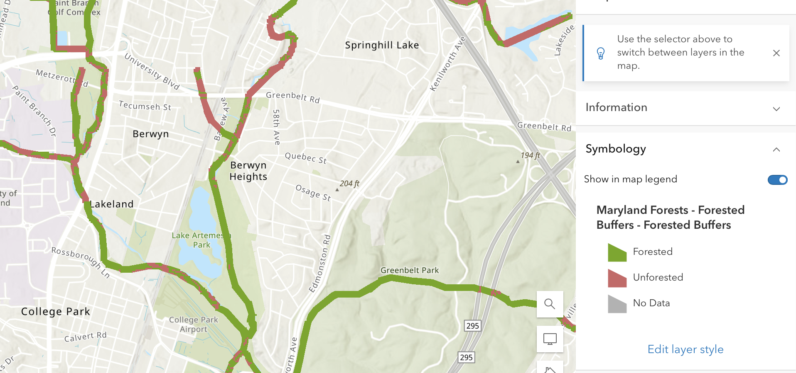

**Layer 1**: The dataset displays the presence and absence of forested areas within a 100 foot-buffer of a stream or waterbody. Forested buffers can help protect against flooding by intercepting rainfall and providing a protective zone for existing structures. These buffers can absorb some water, reducing peak runoff during storm events.

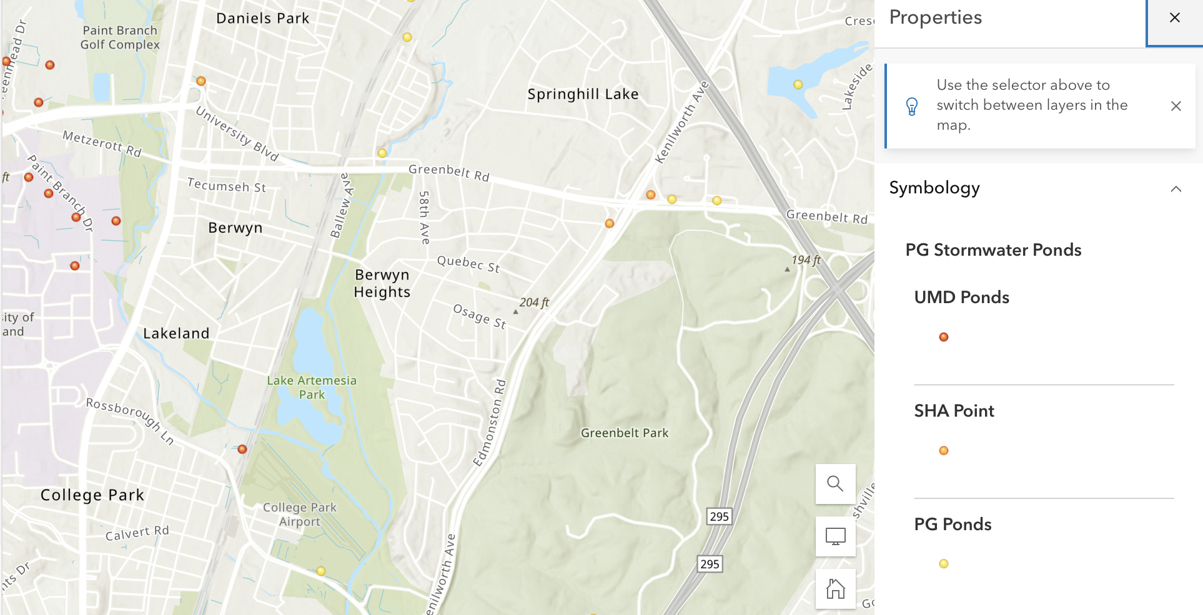

**Layer 2**: This layer shows the existence of stormwater ponds in Prince George’s County. Stormwater ponds collect water during storm events and can reduce runoff.

Maryland Department of Transportation(MDOT)

State Highway Association(SHA)

National Pollutant Discharge Elimination System(NPDES)

Stormwater Best Management Practices(BMP)

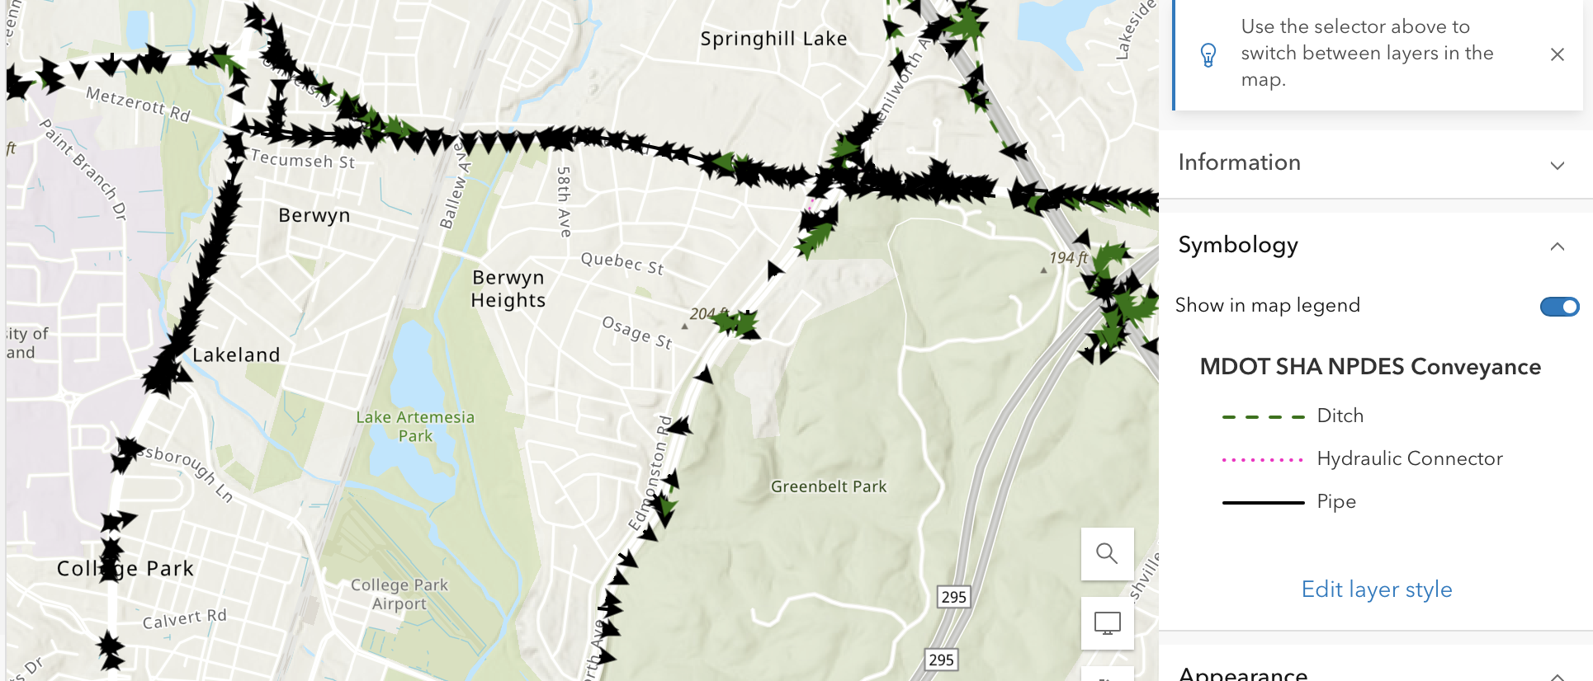

**Layer 3**: Conveyance features to be identified and inventoried include actual, physical features (pipes and ditches) and database connectivity features (hydraulic connectors).

**Pipes** connect structures together in a system to maintain conveyance. Pipes consist of closed storm drain pipes, cross culverts, and driveway culverts. Pipe size, shape, invert, and material are recorded for all pipes.

**Ditches** and open conveyance are channels or flow paths that connect open structures (headwalls, end sections, endwalls, projection pipes, inlets with open backs) in a system to maintain the conveyance. Attributes collected for ditches include material (vegetative, concrete, riprap, etc.), bottom width, and side slope.

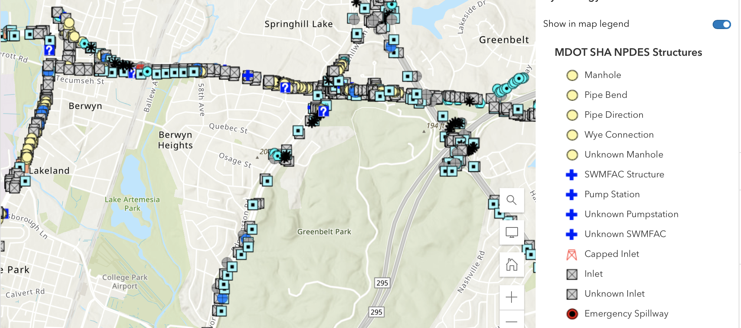

**Layer 4**: Physical stormwater structures to be identified and inventoried include headwalls, endwalls, cross culverts, pumping stations, stormwater risers and weirs, inlets, pipe connections, and manholes.

**End / Head Structures**

An end / head structure is any structure at the upstream or downstream end of a culvert or pipe. These can include headwalls, endwalls, end sections, and projection pipes.

**Endwalls (EW)** are structures that are placed at the downstream end of pipes and culverts to provide a stable or hydraulically desirable exit to the conveyance. Endwalls are usually concrete, but can be constructed of wood or masonry such as brick or concrete block. All wall structures on the downstream side of a culvert or pipe are inventoried as endwalls.

**End Sections (ES)** are structures that transition the ends of pipes into slopes and provide stability to the pipe entrances and outflows. End sections do not affect the hydraulic capacity or efficiency of the pipes.End sections can either be inventoried at the upstream or downstream end of a pipe.

**Projection Pipes (PP)** are not physical structures but represent the upstream and downstream end of a pipe if an end structure on a pipe does not exist. Projection pipes are captured spatially as a feature and represent the ends of pipes.

**Inlet Structures**

Inlets are structures that collect storm drain runoff. Inlets convey the runoff to closed storm drain systems, open conveyance, or outfalls.

**Inlets (IN)** are hydraulic structure chambers below surface grade that collect storm drain runoff. An inlet either has a grate or open sides / curb to allow runoff to enter the storm drain system. Inlets are often constructed of concrete, masonry brick, or concrete block.

**Spring Heads (SH)** are inventoried as inlets. Spring heads are inventoried only where they emerge and are connected to a storm drain system. Spring heads are inventoried because they provide evidence for the presence of ground water for dry weather flows during illicit discharge field screening operation.

**Connection Structures**

A connection structure is a storm drain structure that connects conveyance (pipes and ditches) within a system and is not an inlet, riser, weir, or pumping station. These can include manholes, ditch intersections, junction boxes, pipe connections, wye connections, capped inlets, pipe bends, and pipe directions.

**Manholes (MH)** are hydraulic structures that connect pipes through a system. They are used as access points to a system, to change direction or invert elevations for pipes, as a junction to change pipe size and / or material, and as a junction of multiple pipes to a single pipe. Manholes are frequently paved over or buried, but are still inventoried. Unless it is certain that the manhole does not exist, the manhole is inventoried. Manholes with lids that have designed holes to allow runoff to enter are inventoried as manholes and not inlets.

**Ditch Intersections (ID)** are geographic representations of where ditches meet, begin, or end a system and are captured as point features. These features are used to define the extents of ditches.

**Junction Boxes (JB)** are underground hydraulic structures that connect pipes through a system. They are used to change direction or invert elevations for pipes, to change pipe size and / or material, and to connect multiple pipes to a single pipe.

**Pipe Connections (PC)** are locations throughout the conveyance of a system where two or more pipes connect. A pipe connection is also captured at the location where a closed storm drain pipe connects to a culvert or stream crossing.

**Wye Connections (YC)** are hydraulic structures that join two pipes together within a system’s conveyance.

**Capped Inlets (CI)** are inlets that have been capped for some reason, such as roadway widening. These are not inventoried as inlets, but as connectors. Capped inlets should be identified from the contract drawings and should not be assumed in the field.

**Pipe Bends (PB)** are locations along a conveyance where a pipe makes a significant turn in direction and are usually shown on contract plan sheets. Pipe bends can be actual physical features or used to facilitate an accurate representative of the pipe. Pipe bends will be identified from contract drawings and will be at the discretion of the team to determine if a pipe bend is necessary. Pipe bends can also be used if the pipe turns and no pipe bend feature is identified on the plans, such as pipes that make slight S-turns.

**Pipe Directions (PD)** are not physical features in the field, but represent connectivity with private storm drain systems when an upstream or downstream private structure cannot be located in the field. If an SHA storm drain flows into or out of a private storm drain structure, then the first or last structure in the private system is inventoried.

**Control Structures**

A control structure is any type of structure that controls flows. Control structures will most often be riser, weir, or emergency spillway structures. Although other structures such as inlets, headwalls, end sections, projection pipes, and pump stations can function as control structures as well.

**Riser Structures (SW)** are vertical structures extending from the bottom of a stormwater BMP that are used to control discharge rates from a BMP for specified design storms. Riser structures are normally constructed of concrete or corrugated metal. Riser structures may or may not have low-flow orifices and / or trash racks. Typically riser structures are designed with different type of inflow devises to control flow out of stormwater BMPs and are normally connected to an outfall pipe

**Weir Structures (SW)** are earthen notches or other water barriers, such as a concrete or gabion wall structure, in a berm dam through which flow of water out of a stormwater BMP is regulated and controlled. Weirs are commonly constructed from concrete, wood, metal, earthen, or riprap. Weir structures may or may not have low-flow orifices and / or trash racks.

**Emergency Spillways (EM)** are depressions or notches in cut that convey stormwater BMP overflow in a controlled manner, rather than allowing it to overtop the embankment. The material of an emergency spillway can be concrete, earthen, or riprap.

**Pumping Stations (PS)** are mechanical pumps stored in a pump house that pump or lift stormwater uphill to a high point where gravity can again convey flow. Pump stations are considered control structures because they control the quantity of water being pumped out of a BMP. Pump stations are rare and are mostly identified from contract drawings.

Each layer represents different aspects we believe are important to the stormwater issue in Berwyn Heights and surrounding areas. This can give the town a good representation of what further action needs to be done now to improve the issues relating to stormwater.

**Recommendations**

From our research on the stormwater issue in Berwyn Heights, the major problem with the stormwater is drainage issues in Berwyn Heights. Hopefully, town officials can use this map to gain a general sense of what the area and surrounding areas have. The idea has been pushed that residents need to make improvements and renovations to their land in order to protect the area from stormwater damage. Prince George’s County operates a Rain Check Rebate Program which provides funding and technical advice to homeowners who are implementing one or more of several types of stormwater runoff improvements including installation of rain barrels, cisterns, green roofs, permeable pavement or rain gardens, or planting of new trees. The town should also allocate funding for stormwater flooding prevention structures, so the responsibility is not solely put on residents.

**Conclusions**

Using our skills, we believe that we created a dashboard that would visualize stormwater aspects of Berwyn Heights that would be helpful to the town by giving information on what they have or what is missing. Learning that we would be using a new software, ArcGIS, to build our final deliverable brought some explorations for us because we got to experiment with a new tool to create our dashboard. Given the resources, we created a visual based on what we could work with. We hope that in the future, the ArcGIS map can be built upon with new data from the town. Our dashboard focused on hydrology aspects, but hopefully, future work can be done on other parts of stormwater such as looking at how vegetation can affect stormwater.